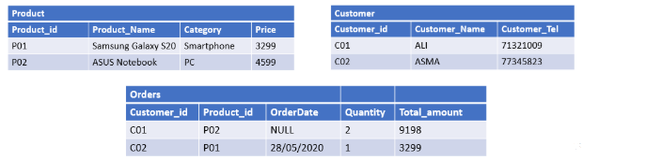

INSERT INTO Product VALUES

(‘P01’ , ‘Samsung Galaxy S20’ , ‘Smatphone’ , 3299);

INSERT INTO Product VALUES

(‘P02’, ‘ASUS Notebook’ , ‘PC’ , 4599);

INSERT INTO Customer VALUES

(‘C01’ , ‘ALI’ , 71321009);

INEST INTO Customer VALUES

(‘C02’ , ‘ASMA’ , 73345823);

INSERT INTO Orders (Customer_id, Product_id, Quantity,Total_amount)

VALUES (‘C01’, ‘P02’ , 2 , 9198)

INSERT INTO Orders VALUES

(‘C02’, ‘P01’, ‘28/05/2020’ , 1, 3299)